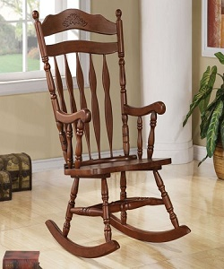

Simple Rocking Chair

$18.78

Availability: In stock

Description

Simple wood rocking chair. This versatile lounge chair can be used as part of a living room seating arrangement or as an accent piece in a bedroom. Versatile to fit in any room setting. Pure wood chair.